**Supporting information for “Radium Sorption to Iron (hydr)oxides, Pyrite, and Montmorillonite: Implications for Mobility”**

**Authors:**

**Michael A. Chen**

**Benjamin D. Kocar**

**Number of Pages: 9**

**Number of Figures: 2**

**Number of Tables: 4**

**Experimental Methods:** Ferrihydrite naturally exists as a hydrated mineral,1 thus it was important to prepare and handle the mineral such that its hydration was preserved. Here, a ferrihydrite slurry was synthesized by adding 0.4 M NaOH to a 50 mM ferric chloride hexahydrate solution, and then centrifuging and washing the resulting precipitate three times with 18 MΩ water, resulting in a thick paste of ferrihydrite. A small volume (<100 mL) of DI water was added to create a slurry consistency. The iron content of the prepared ferrhydrite slurry was determined through colorimetry (ferrozine method)2 and stirred slurry aliquots were added directly to the experiments to achieve the desired mineral mass.

Goethite was prepared through slow air-oxidation of a 50 mM Fe2+ and 100 mM bicarbonate solution over two days, and then centrifuged and washed three times with 18 MΩ water. The resultant slurry was then oven dried at 70 °C for two hours, resulting in a mineral powder that was then gently ground with a mortar and pestle to homogenize the sample. This dried sample was added directly to experimental bottles.

There are well established methods for preparing natural clay mineral samples for use in experimental work.3 The STx-1b montmorillonite ordered from the Clay Minerals Society was originally a calcium montmorillonite, but was converted to sodium montmorillonite for easier comparison to other studies. This was achieved by first dispersing the clay with 1 M NaCl, then siphoning the suspended <0.2 µm clay fraction by successively centrifuging and suspending the clay eight times in DI water. The suspension was flocculated with saturated NaCl, and excess solution removed via centrifugation. The clay suspension was then treated with a 1 M sodium acetate solution (pH 5) to remove residual carbonate minerals. The resulting Na-equilibrated montomorillonite was then centrifuged and equilibrated with the experimental background solution (10 mM NaCl), centrifuged again, dried at 70 °C overnight, and then gently powdered using mortar and pestle. This dried powder was added directly to the experiments. Results of the kinetic experiments involving sodium montmorillonite are shown in figure S1, showing that over a 24 hour period, the water Ra concentrations stabilize.

All prepared minerals’ surface area was measured using a BET surface area analyzer (table S1). Ferrihydrite was dried for this analysis, and pyrite was held anaerobically until analysis.

Displacement of H+ from mineral surfaces can cause sorption experiments to drift in pH over time, requiring some pH adjustment. Following the experimental period (24 hours), pH was checked and re-titrated to the desired value if necessary; if the pH deviated more than 0.1 pH units, the bottle was allowed to re-equilibrate for 15 minutes after titration, and the re-titration process repeated. This process was sufficient to ensure the experimental pHs described.

The composition of the various background solutions used in sorption experiments are reported in table S2. Artificial groundwater, brackish water, and seawater were diluted from a 2x artificial seawater stock. The ratio of individual cations was not selected to match a specific location, but rather to simulate common groundwater and seawater cations in “typical” environmental ratios. The cations selected for single competing cation experiments reported in figure 2 of the main text were selected based on the composition of the artificial waters. Only chloride salts of these cations were used to make solutions to limit interference from different anions.

Control experiments without any mineral were also performed to examine Ra sorption to the serum bottle surface. Some pH dependent sorption was observed, but was limited in comparison to the minerals studied. Given the limited observed sorption within controls, no corrections to data were made. Serum bottles and caps were scrubbed in detergent solution, rinsed, soaked in 2% HNO3 for at least 1 hour, rinsed 3 times with 18 MΩ water, and then air dried before usage in experiments. This procedure was sufficient to prevent Ra and mineral cross contamination across experiments.

**Analytical Methods:** Background concentrations Ra were measured through scintillation counting to develop a limit of blank of 1.4 counts per second (cps). From this, we developed a blank derived minimum detection limit of 0.209 Bq, as defined by the EPA (EPA 821-R-16-006).4 A Canberra low energy germanium detector and multichannel analyzer was calibrated using a multinuclide standard from Eckert and Ziegler ([www.ezag.com)](http://www.ezag.com)), and 226Ra activities for scintillation counting standards were determined using Canberra Genie software using the 186 keV peak.

**Comparison of Sorption Experiment Results:** Fitted Kd and Ksa values developed from isotherm experiments are reported in table S1, with the corresponding fits plotted for each mineral in figure S2. Errors reported for Kd values are the standard error of regression produced by the least squares fitting function, linregress, from the python package SciPy, and Ksa errors the Kd normalized by mineral specific surface area. These values were also used for error bar plots in the main text (figure 1).

Our results are compared with literature K­d values (Table S3), which are mostly derived from experimental isotherms. In some cases, a Kd value was not reported, but could have been fit in the same way we fit our data here. The greatest number of reported Kd values are found for the iron (hydr)oxides; however, there are significant differences in the experimental conditions (solid-solution loading, background electrolyte composition, etc.). Notable similarities and differences are explained in the main text.

**Surface Complexation Modeling:** Experimental sorption data was fit by varying Ra sorption reaction constants.5,6 Surface area and site densities, while fittable parameters in the models, were not varied, and were constrained with surface areas reported in table S1 and site densities previously determined in the literature (list these or refer to table). For exchange sites used montmorillonite modeling, the CEC value given by the The Clay Minerals Society (clays.org) was used. Solution complexation behavior was accounted for using the SIT database, which includes radium carbonate, sulfate, chloride, and hydroxide complexes, albeit these solution complexes had little impact over the experimental conditions considered.

The surface complexes used to model Ra sorption and impact of competing ions are reported in table S4. Ra complexation constants were fitted to match sorption isotherm data or circumneutral, varied background solution data, and are also reported for both methods of fitting in table S4. Constants for the other surface complexes are drawn from the literature, however many of the models used in the literature use alternative representations of the mineral surface (ie. CD-MUSIC, or extended triple layer models), thus the constants are not readily applicable to the generalized two layer models used here. Only constants fit using a generalized two layer model and similar surface complexes were used to model background electrolyte competition. Carbonate surface complexes were only included in the SCM for goethite, as the goethite synthesis method involves high concentrations of carbonate to buffer pH, resulting in carbonate surface complexes that persist even after washing.7 Some cations used experimentally (e.g. Na+, K+) did not have published constants, but clearly demonstrated differential amounts of sorption (Figure 2, main text). In these cases, no constants were fit or used, underscoring a potential limitation for using these models for predicting Ra transport in natural systems.

We also considered a few other mineral-specific SCMs to attempt replication of results reported in the main text. For the iron oxides, single site models featuring tetradentate surface coordination have been used in both generalized double layer models, and extended triple layer models to fit divalent cation sorption.6,8,9 For montmorillonite, many models have been proposed, but no standardized SCM has been adopted, some which follow the non-electrostatic method used here, others using various means of representing the permanent negative charge of the clay surface.10,11 While in some cases use of these models improved fits to our data, the lack of spectroscopic studies for Ra combined with the limited database of constants for competing ions effectively precluded the use of these alternative models. The non-standardization of these different SCMs and their calibration also impeded any efforts to test their viability for predicting transport of Ra in the different geochemical conditions tested here.12 Thus, we elected to use relatively “simple” models that are well established in the literature, and have a wider variety of available reaction constants that can be used to model the effect of different competing cations. That these simpler models failed to provide meaningful prediction of the impact of different solution conditions (main text) suggests that further detailed study of Ra sorption to mineral surfaces is needed to constrain these SCMs. In particular, constants to explain the differences in Na and K sorption, as well as better understanding of mineral specific Ra surface complexes would improve these models’ predictive capability.

**Table S1. Mineral Surface Areas and Fitted Kd and Ksa values**

|  |  |  |  |  |
| --- | --- | --- | --- | --- |
| Mineral | Surface Area (m2/g) | pH | Kd (mL/g) | Ksa (mL/m2) |
| Ferrihydrite | 383 | 3 | 405±72 | 1.06±0.19 |
|  | 5 | 526±48 | 1.37±0.13 |
|  | 7 | 2420±210 | 6.33±0.55 |
|  | 9 | 302000±29000 | 789±76 |
| Goethite | 146 | 3 | 2.77±7.86 | 0.019±0.054 |
|  | 5 | 400±42 | 2.73±0.29 |
|  | 7 | 679±52 | 4.64±0.36 |
|  | 9 | 12400±700 | 84.8±4.8 |
| Sodium Montmorillonite | 50.2 | 3 | 7740±860 | 154±17 |
|  | 5 | 20000±2000 | 398±40 |
|  | 7 | 22600±300 | 451±6 |
|  | 9 | 25400±1500 | 507±29 |
| Pyrite | 0.07 | 3 | 156±18 | 2280±260 |
|  | 5 | 400±29 | 5840±420 |
|  | 7 | 579±16 | 8450±230 |
|  | 9 | 574±29 | 8380±430 |

**Table S2: Major Salt Concentrations in the different background treatments**

|  |  |  |  |  |  |  |
| --- | --- | --- | --- | --- | --- | --- |
| **Experiment** | **Na (mM)** | **K (mM)** | **Mg (mM)** | **Ca (mM)** | **Sr (mM)** | **Cl (mM)** |
| NaCl | 10 |  |  |  |  | 10 |
| KCl |  | 10 |  |  |  | 10 |
| MgCl2 |  |  | 10 |  |  | 20 |
| CaCl2 |  |  |  | 10 |  | 20 |
| SrCl2 |  |  |  |  | 10 | 20 |
| AGW | 5 | 2 | 0.5 | 0.5 | 0.0001 | 9 |
| ABW | 50 | 20 | 5 | 5 | 0.001 | 90 |
| ASW | 400 | 160 | 40 | 40 | 0.008 | 720 |

**Table S3. Comparison of Literature Ra Sorption Experiments and Fitted Kd Values**

|  |  |  |  |  |  |
| --- | --- | --- | --- | --- | --- |
| Mineral | Solid/Solution Ratio (mg/L) | Background Solution | pH | Kd (mL/g) | Source |
| Ferrihydrite | 300 | 10 mM NaCl | 7 | 2420 | This study |
| 300 | 10 mM NaCl | 9 | 302000 | Experimental |
| 25000 | Seawater | 8.25 | 1535 | 13 |
| 10000 | 100 mM NaClO4 | 7 | 1440 | 6 |
| Goethite | 300 | 10 mM NaCl | 3 | 2.77 | Experimental |
| 300 | 10 mM NaCl | 5 | 400 | Experimental |
| 300 | 10 mM NaCl | 7 | 679 | Experimental |
| 300 | 10 mM NaCl | 9 | 12400 | Experimental |
| 25000 | Seawater | 8.25 | 20 | 13 |
| 10000 | 100 mM NaClO4 | 7 | 50.6 | 6 |
| 500000 | “pH 1 solution” | 1 | 0.752 | 14 |
| 500000 | “pH 10 solution” | 10.1 | 544 | 14 |
| Lepidocrocite | 25000 | Seawater | 8.25 | 174 | 13 |
| Hematite | 25000 | Seawater | 8.25 | 75 | 13 |
| Sodium Montmorillonite | 300 | 10 mM NaCl | 5 | 20000 | Experimental |
| 300 | 10 mM NaCl | 7 | 22600 | Experimental |
| 3333 | 10 mM NaCl | 5.25 | 9700 | 15 |
| 50000 | 10 mM NaCl | 6.5 | 3724 | 16 |

**Table S4: Surface complexation reactions and constants from data fitting**

|  |  |  |  |  |
| --- | --- | --- | --- | --- |
| Reactions | Sites (mol/g) | log K Isotherm | Lg K  Salinity | Source |
| Ferrihydrite  Protonation  ≡FhysOH + H+ ⇄ ≡FhysOH2+  ≡FhysOH ⇄ ≡FhysO- + H+  ≡FhywOH + H+ ⇄ ≡FhywOH2+  ≡FhywOH ⇄ ≡FhywO- + H+  Radium  ≡FhysOH + Ra2+ ⇄ ≡FhysOHRa2+  ≡FhywOH + Ra2+ ⇄ ≡FhywOHRa2+ H+  ≡FhywOH + Ra2+ + H2O ⇄ ≡FhywOHRaOH + 2H+  Competing Ions  ≡FhysOH + Ca2+ ⇄ ≡FhysOHCa2+  ≡FhywOH + Ca2+ ⇄ ≡FhywOHCa++ H+  ≡FhywOH + Mg2+ ⇄ ≡FhywOHMg++ H+  ≡FhysOH + Sr2+ ⇄ ≡FhysOHSr2+  ≡FhywOH + Sr2+ ⇄ ≡FhywOHSr++ H+  ≡FhywOH + Sr2+ H2O ⇄ ≡FhywOHSrOH + 2H+ | 1.87E-3  4.67E-5 | 7.92  -8.93  7.92  -8.93  6.7  -2.8  -15  4.97  -5.85  4.6  5.01  -6.58  -17.6 | 7.92  -8.93  7.92  -8.93  5.7  -11.0  -9.4  4.97  -5.85  4.6  5.01  -6.58  -17.6 | A  A  A  A  Fitting  Fitting  Fitting  A  A  A A  A  A |
| Goethite  Protonation  ≡GoeOH + H+ ⇄ ≡GoeOH2+  ≡GoeOH ⇄ ≡GoeO- + H+  Radium  ≡GoeOH + Ra2+ ⇄ ≡GoeOHRa+ + H+  ≡GoeOH + Ra2+ ⇄ ≡GoeOHRa2+  Competing Ions  ≡GoeOH + Ca2+ ⇄ ≡GoeOHCa+ + H+  ≡GoeOH + Ca2+ ⇄ ≡GoeOHCa2+  ≡GoeOH + Mg2+ ⇄ ≡GoeOHMg+ + H+  ≡GoeOH + Mg2+ ⇄ ≡GoeOHMg2+  ≡GoeOH + Sr2+ ⇄ ≡GoeOHSr+ + H+  ≡GoeOH + Sr2+ ⇄ ≡GoeOHSr2+  ≡GoeOH + 2H+ + CO32- ⇄ ≡GoeOCOOH+ H2O  ≡GoeOH + H+ + CO32- ⇄ ≡GoeOCOO- ­­+ H2O | 4.87E-4 | 6.93  -9.65  -3.9  3.5  -6.48  3.98  -3.02  5.24  -5.44  3.59  20.78  12.71 | 6.93  -9.65  -2.5  -6.6  -6.48  3.98  -3.02  5.24  -5.44  3.59  20.78  12.71 | B  B  Fitting  Fitting  B  LFER, B  B  LFER, B  B  LFER, B  C  C |
| Sodium Montmorillonite  Exchange  2 ≡Clay-Na + Ra2+ ⇄ ≡Clay2-Ra + 2 Na+  2 ≡Clay-Na + Ca2+ ⇄ ≡Clay2-Ca + 2 Na+  2 ≡Clay-Na + Mg2+ ⇄ ≡Clay2-Mg + 2 Na+  ­Surface Protonation  ≡ClaysOH + H+ ⇄ ≡ClaysOH2+  ≡ClaysOH ⇄ ≡ClaysO- + H+  ≡Clayw1OH + H+ ⇄ ≡Clayw1OH2+  ≡Clayw1OH ⇄ ≡Clayw1O- + H+  ≡Clayw2OH + H+ ⇄ ≡Clayw2OH2+  ≡Clayw2OH ⇄ ≡Clayw2O- + H+  Radium  ≡ClaysOH + Ra2+ ⇄ ≡ClaysORa+ + H+  ≡Clayw1OH + Ra2+ ⇄ ≡Clayw1ORa+ + H+  Competing Ions ≡ClaysOH + Mg2+ ⇄ ≡ClaysOMg+ + H+  ≡Clayw1OH + Mg2+ ⇄ ≡Clayw1OMg+ + H+  ≡ClaysOH + Ca2+ ⇄ ≡ClaysOCa+ + H+  ≡Clayw1OH + Ca2+ ⇄ ≡Clayw1OCa+ + H+  ≡ClaysOH + Sr2+ ⇄ ≡ClaysOSr+ + H+  ≡ClaysOH + Sr2+ + H2O ⇄ ≡ClaysOSrOH+ 2H+  ≡Clayw1OH + Sr2+ ⇄ ≡Clayw1OSr+ + H+  ≡Clayw1OH + Sr2+ + H2O ⇄ ≡Clayw1OSrOH+ 2H+ | 8.45E-4  2E-6  4E-5  4E-5 | 0.2  0.5  0.4  4.5  -7.9  4.5  -7.9  6.0  -10.5  0.0  -2.1  -2.4  -5.2  -3.4  -5.2  -3.9  -16.7  -6.8  -20.8 | 0.2  0.5  0.4  4.5  -7.9  4.5  -7.9  6.0  -10.5  -0.9  -1.9  -2.4  -5.2  -3.4  -5.2  -3.9  -16.7  -6.8  -20.8 | Fitting, D  E  F  G  G  G  G  G  G  Fitting  Fitting  LFER, H  LFER, H  LFER, H  LFER, H  LFER, H  LFER, H  LFER, H  LFER, H |

Notes: LFER: Indicates constants was fitted using a linear free energy relationship from the denoted source. Sources: A: From Dzombak and Morel, 1990.17 B: From Mathur and Dzombak, 2006.18 C: From Van Geen, Robertson, and Leckie, 1994.19 D: Number of exchange sites from CEC reported by Clays.org for STx-1b Calcium Montmorillonite. Exchange reaction fitted to match low pH sorption (ie, sorption without surface site impacts). E: From Tournassat et al., 2004.20 F: From Charlet and Tournassat, 2005.21 G: From Bradbury and Baeyens, 1997.22 H: From Bradbury and Baeyens, 2005.23

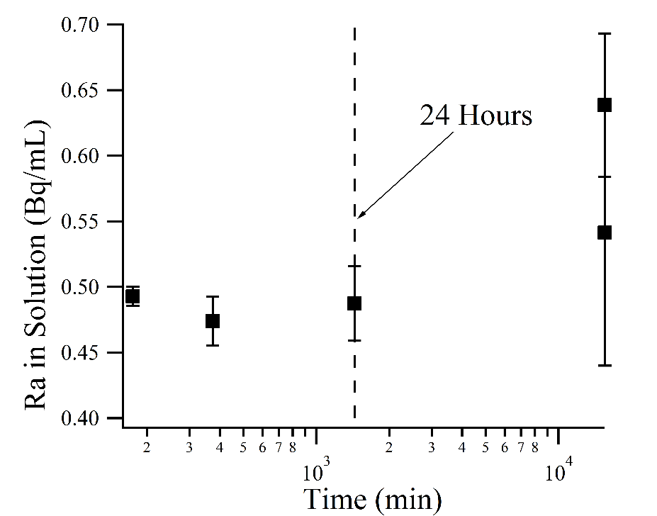Figure S1. Radium sorption to Sodium Montmorillonite as a function of time.

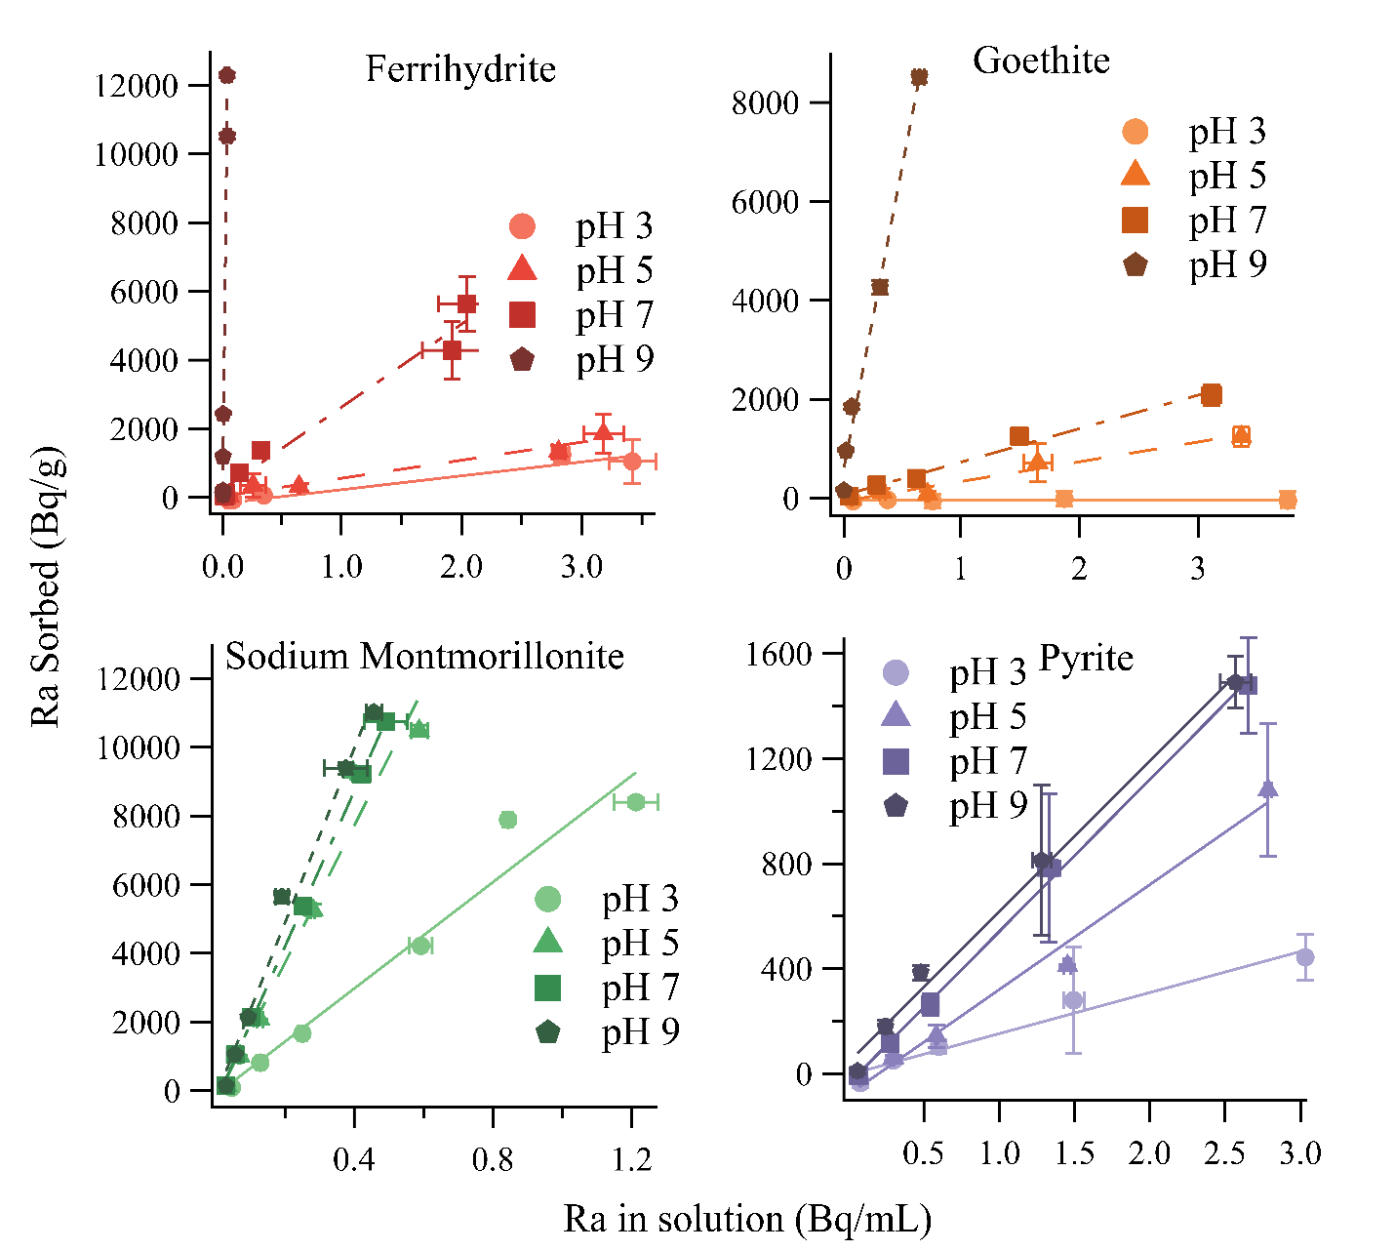

Figure S2: Results of isotherm experiments with linear fits.

**References**

(1) Michel, F. M.; Ehm, L.; Antao, S. M.; Lee, P. L.; Chupas, P. J.; Liu, G.; Strongin, D. R.; Schoonen, M. A. A.; Phillips, B. L.; Parise, J. B. The structure of ferrihydrite, a nanocrystalline material. *Science* **2007**, *316* (5832), 1726–1729 DOI: 10.1126/science.1142525.

(2) Stookey, L. L. Ferrozine---a new spectrophotometric reagent for iron. *Anal. Chem.* **1970**, *42* (7), 779–781 DOI: 10.1021/ac60289a016.

(3) Klute, A.; Kunze, G. W.; Dixon, J. B. Pretreatment for Mineralogical Analysis. In *Methods of Soil Analysis Part 1 - Physical and Mineralogical Methods*; Soil Science Society of America, American Society of Agronomy, 1986.

(4) United States Environmental Protection Agency. *Definition and Procedure for the Determination of the Method Detection Limit, Revision 2*; Washington, DC, 2016.

(5) Bradbury, M. H.; Baeyens, B.; Geckeis, H.; Rabung, T. Sorption of Eu(III)/Cm(III) on Ca-montmorillonite and Na-illite. Part 2: Surface complexation modelling. *Geochim. Cosmochim. Acta* **2005**, *69* (23), 5403–5412 DOI: 10.1016/j.gca.2005.06.031.

(6) Sajih, M.; Bryan, N. D. D.; Livens, F. R. R.; Vaughan, D. J. J.; Descostes, M.; Phrommavanh, V.; Nos, J.; Morris, K. Adsorption of radium and barium on goethite and ferrihydrite: A kinetic and surface complexation modelling study. *Geochim. Cosmochim. Acta* **2014**, *146*, 150–163 DOI: 10.1016/j.gca.2014.10.008.

(7) Schwertmann, U.; Cornell, R. *Iron Oxides in the Laboratary*; Wiley-VCH Verlag GmbH: Weinheim, Germany, 2000.

(8) Sverjensky, D. A. Prediction of the speciation of alkaline earths adsorbed on mineral surfaces in salt solutions. *Geochim. Cosmochim. Acta* **2006**, *70* (10), 2427–2453 DOI: 10.1016/j.gca.2006.01.006.

(9) Carroll, S. a; Roberts, S. K.; Criscenti, L. J.; O’Day, P. a. Surface complexation model for strontium sorption to amorphous silica and goethite. *Geochem. Trans.* **2008**, *9*, 2 DOI: 10.1186/1467-4866-9-2.

(10) Kraepiel, A.; Keiler, K. C.; Morel, F. M. M. A Model for Metal Adsorption on Montmorillonite. *J. Colloid Interface Sci.* **1999**, *210* (1), 43–54 DOI: 10.1006/jcis.1998.5947.

(11) Tournassat, C.; Grangeon, S.; Leroy, P.; Giffaut, E. Modeling specific ph dependent sorption of divalent metals on montmorillonite surfaces. a review of pitfalls, recent achievements and current challenges. *Am. J. Sci.* **2013**, *313* (5), 395–451 DOI: 10.2475/05.2013.01.

(12) Duster, T. A. An Integrated Approach to Standard Methods, Materials, and Databases for the Measurements Used To Develop Surface Complexation Models. *Environ. Sci. Technol.* **2016**, *50* (14), 7274–7275 DOI: 10.1021/acs.est.6b02669.

(13) Beck, A. J.; Cochran, M. a. Controls on solid-solution partitioning of radium in saturated marine sands. *Mar. Chem.* **2013**, *156*, 38–48 DOI: 10.1016/j.marchem.2013.01.008.

(14) Nirdosh, I.; Trembley, W.; Johnson, C. Adsorption-desorption studies on the 226Ra-hydrated metal oxide systems. *Hydrometallurgy* **1990**, *24* (2), 237–248 DOI: 10.1016/0304-386X(90)90089-K.

(15) Tamamura, S.; Takada, T.; Tomita, J.; Nagao, S.; Fukushi, K.; Yamamoto, M. Salinity dependence of 226Ra adsorption on montmorillonite and kaolinite. *J. Radioanal. Nucl. Chem.* **2013**, *299* (1), 569–575 DOI: 10.1007/s10967-013-2740-3.

(16) Ames, L.; McGarrah, J.; Walker, B. Sorption of trace constituents from aqueous solutions onto secondary minerals. II. Radium. *Clays Clay Miner.* **1983**, *31* (5), 335–342.

(17) Dzombak, D.; Morel, F. *Surface Complexation Modeling: Hydrous Ferric Oxide*; Wiley: New York, NY, 1990.

(18) Mathur, S. S.; Dzombak, D. A. Surface complexation modeling: Goethite; 2006; pp 443–468.

(19) van Geen, A.; Robertson, A. P.; Leckie, J. O. Complexation of carbonate species at the goethite surface: Implications for adsorption of metal ions in natural waters. *Geochim. Cosmochim. Acta* **1994**, *58* (9), 2073–2086 DOI: 10.1016/0016-7037(94)90286-0.

(20) Tournassat, C.; Ferrage, E.; Poinsignon, C.; Charlet, L. The titration of clay minerals: II. Structure-based model and implications for clay reactivity. *J. Colloid Interface Sci.* **2004**, *273* (1), 234–246 DOI: 10.1016/j.jcis.2003.11.022.

(21) Charlet, L.; Tournassat, C. Fe(II)-Na(I)-Ca(II) cation exchange on montmorillonite in chloride medium: Evidence for preferential clay adsorption of chloride - Metal ion pairs in seawater. *Aquat. Geochemistry* **2005**, *11* (2), 115–137 DOI: 10.1007/s10498-004-1166-5.

(22) Bradbury, M. H.; Baeyens, B. A mechanistic description of Ni and Zn sorption on Part II: modelling. *J. Contam. Hydrol.* **1997**, *27*, 223–248 DOI: 10.1016/S0169-7722(97)00008-9.

(23) Bradbury, M. H.; Baeyens, B. Modelling the sorption of Mn(II), Co(II), Ni(II), Zn(II), Cd(II), Eu(III), Am(III), Sn(IV), Th(IV), Np(V) and U(VI) on montmorillonite: Linear free energy relationships and estimates of surface binding constants for some selected heavy metals and actinide. *Geochim. Cosmochim. Acta* **2005**, *69* (4), 875–892 DOI: 10.1016/j.gca.2004.07.020.